**Industrial Internship Report on**

**”URL Shortener”**

**Prepared by**

**Maharaj P S**

|  |
| --- |
| *Executive Summary* |
| This report provides details of the Industrial Internship provided by upskill Campus and The IoT Academy in collaboration with Industrial Partner UniConverge Technologies Pvt Ltd (UCT).  This internship was focused on a project/problem statement provided by UCT. We had to finish the project including the report in 6 weeks’ time.  My project was URL Shortener which sort the URL length.  This internship gave me a very good opportunity to get exposure to Industrial problems and design/implement solution for that. It was an overall great experience to have this internship. |

**TABLE OF CONTENTS**

1 Preface 3

2 Introduction 4

2.1 About UniConverge Technologies Pvt Ltd 4

2.2 About upskill Campus 8

2.3 Objective 9

2.4 Reference 9

2.5 Glossary 10

3 Problem Statement 11

4 Existing and Proposed solution 12

5 Proposed Design/ Model 13

5.1 High Level Diagram (if applicable) 13

5.2 Low Level Diagram (if applicable) 13

5.3 Interfaces (if applicable) 13

6 Performance Test 14

6.1 Test Plan/ Test Cases 14

6.2 Test Procedure 14

6.3 Performance Outcome 14

7 My learnings 15

8 Future work scope 16

# Preface

**Working Experience Showcase:**

During my six-week internship, I immersed myself in a diverse array of Python libraries, honing my skills in numPy, pandas, Matplotlib, and bitly_api, while also exploring new libraries as the need arose. This hands-on experience provided invaluable insights into data manipulation, visualization, and web interaction.

One notable project I contributed to during my internship was the development of a URL shortener using Python. This project involved converting long URLs into shorter, more manageable links. My responsibilities encompassed designing a user-friendly interface for inputting long URLs and displaying their shortened counterparts. Additionally, I played a crucial role in implementing a robust database system to store the mappings between original and shortened URLs, ensuring efficient retrieval and management of link data.

Furthermore, I actively participated in the development of functions essential for generating unique shortened URLs and handling redirection seamlessly. This required a deep understanding of Python's capabilities and a meticulous approach to coding practices.

One of the most rewarding aspects of this internship was the opportunity to showcase my newfound skills and knowledge on various platforms. Through this project, I not only demonstrated proficiency in Python programming but also showcased my ability to tackle real-world challenges and deliver effective solutions.

The UniCoverage Technologies Pvt. Ltd provided an enriching environment where I could leverage my Python expertise to contribute meaningfully to projects like the URL shortener. This experience has undoubtedly bolstered my confidence in Python programming and equipped me with valuable skills for future endeavors in the field.

Thank to all (Ankit, Prabha Singh), who have helped you directly or indirectly.

# Introduction

## About UniConverge Technologies Pvt Ltd

A company established in 2013 and working in Digital Transformation domain and providing Industrial solutions with prime focus on sustainability and RoI.

For developing its products and solutions it is leveraging various**Cutting Edge Technologies e.g. Internet of Things (IoT), Cyber Security, Cloud computing (AWS, Azure), Machine Learning, Communication Technologies (4G/5G/LoRaWAN), Java Full Stack, Python, Front end**etc.

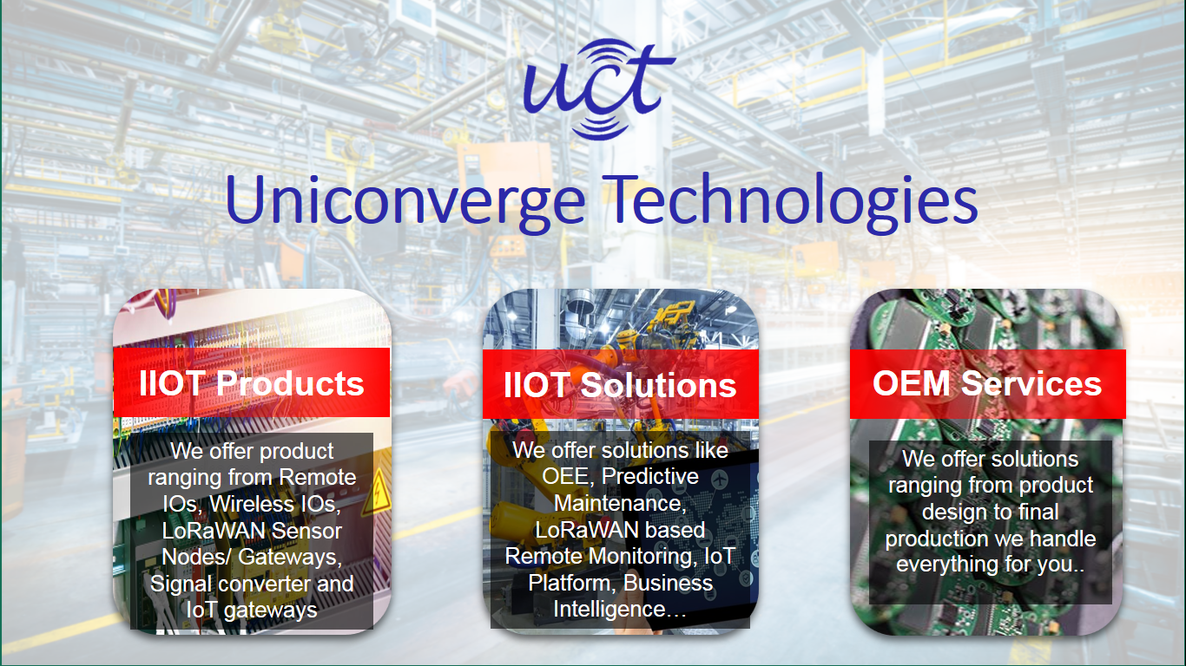

1. UCT IoT Platform **(****)**

**UCT Insight** is an IOT platform designed for quick deployment of IOT applications on the same time providing valuable “insight” for your process/business. It has been built in Java for backend and ReactJS for Front end. It has support for MySQL and various NoSql Databases.

* It enables device connectivity via industry standard IoT protocols - MQTT, CoAP, HTTP, Modbus TCP, OPC UA
* It supports both cloud and on-premises deployments.

It has features to  
• Build Your own dashboard  
• Analytics and Reporting  
• Alert and Notification  
• Integration with third party application(Power BI, SAP, ERP)  
• Rule Engine

 

1. **Smart Factory Platform (****)**

Factory watch is a platform for smart factory needs.

It provides Users/ Factory

* with a scalable solution for their Production and asset monitoring
* OEE and predictive maintenance solution scaling up to digital twin for your assets.
* to unleased the true potential of the data that their machines are generating and helps to identify the KPIs and also improve them.
* A modular architecture that allows users to choose the service that they what to start and then can scale to more complex solutions as per their demands.

Its unique SaaS model helps users to save time, cost and money.

 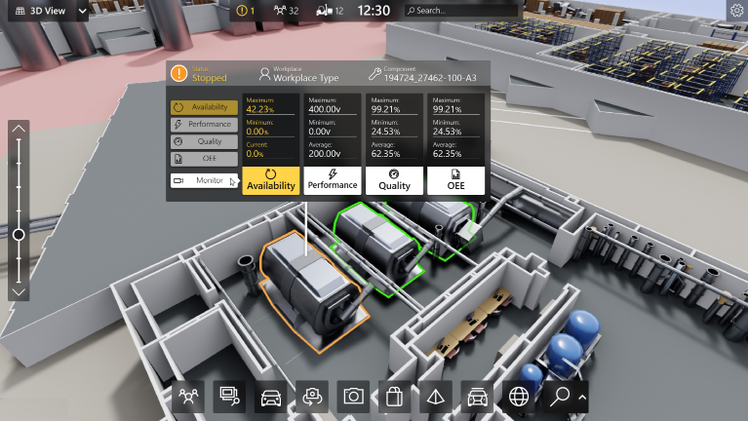

1. 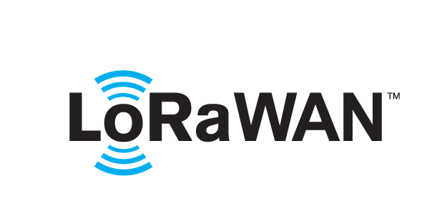 based Solution

UCT is one of the early adopters of LoRAWAN teschnology and providing solution in Agritech, Smart cities, Industrial Monitoring, Smart Street Light, Smart Water/ Gas/ Electricity metering solutions etc.

1. Predictive Maintenance

UCT is providing Industrial Machine health monitoring and Predictive maintenance solution leveraging Embedded system, Industrial IoT and Machine Learning Technologies by finding Remaining useful life time of various Machines used in production process.



## About upskill Campus (USC)

upskill Campus along with The IoT Academy and in association with Uniconverge technologies has facilitated the smooth execution of the complete internship process.

USC is a career development platform that delivers **personalized executive coaching** in a more affordable, scalable and measurable way.



Seeing need of upskilling in self paced manner along-with additional support services e.g. Internship, projects, interaction with Industry experts, Career growth Services

<https://www.upskillcampus.com/>

upSkill Campus aiming to upskill 1 million learners in next 5 year

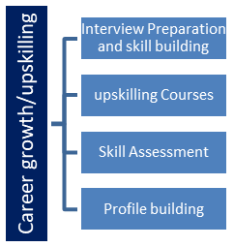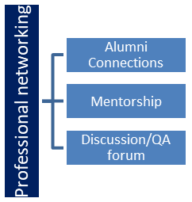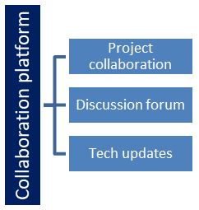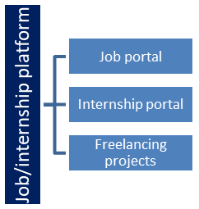

## The IoT Academy

The IoT academy is EdTech Division of UCT that is running long executive certification programs in collaboration with EICT Academy, IITK, IITR and IITG in multiple domains.

## Objectives of this Internship program

The objective for this internship program was to

 ☛ get practical experience of working in the industry.

 ☛ to solve real world problems.

 ☛ to have improved job prospects.

 ☛ to have Improved understanding of our field and its applications.

 ☛ to have Personal growth like better communication and problem solving.

## Reference

[1] https://www.w3schools.com/python/

[2] https://free-url-shortener.rb.gy/

[3]https://www.google.com/search?q=geeks+for+geeks+python&rlz=1C1ONGR_enIN1045IN1045&oq=geeks+for+&gs_lcrp=EgZjaHJvbWUqBwgBEAAYgAQyDQgAEAAYgwEYsQMYgAQyBwgBEAAYgAQyBggCEEUYOTINCAMQABiDARixAxiABDIHCAQQABiABDIHCAUQABiABDIHCAYQABiABDIHCAcQABiABDIHCAgQABiABNIBCTU2NDFqMGoxNagCALACAA&sourceid=chrome&ie=UTF-8

## Glossary

|  |  |
| --- | --- |
| Terms | Acronym |
|  |  |
|  |  |
|  |  |
|  |  |
|  |  |

# Problem Statement

In the assigned problem statement

[Explain your problem statement]

# Existing and Proposed solution

Provide summary of existing solutions provided by others, what are their limitations?

What is your proposed solution?

What value addition are you planning?

## Code submission (Github link):

https://github.com/PSMaharaj/upskill_python_internship

## Report submission (Github link) : https://github.com/PSMaharaj/upskill_python_internship

# Proposed Design/ Model

Given more details about design flow of your solution. This is applicable for all domains. DS/ML Students can cover it after they have their algorithm implementation. There is always a start, intermediate stages and then final outcome.

## High Level Diagram (if applicable)

Figure 1: HIGH LEVEL DIAGRAM OF THE SYSTEM

## Low Level Diagram (if applicable)

## Interfaces (if applicable)

Update with Block Diagrams, Data flow, protocols, FLOW Charts, State Machines, Memory Buffer Management.

# Performance Test

This is very important part and defines why this work is meant of Real industries, instead of being just academic project.

Here we need to first find the constraints.

How those constraints were taken care in your design?

What were test results around those constraints?

Constraints can be e.g. memory, MIPS (speed, operations per second), accuracy, durability, power consumption etc.

In case you could not test them, but still you should mention how identified constraints can impact your design, and what are recommendations to handle them.

## Test Plan/ Test Cases

## Test Procedure

## Performance Outcome

# My learnings

Challenge: Integrating database functionality into the URL shortener application.

Solution: Leveraged SQLAlchemy ORM for database operations, consulted Flask documentation and online tutorials, and iteratively tested database queries to ensure seamless integration.

Challenge: Implementing URL redirection logic and handling edge cases.

Solution: Utilized Flask routing mechanisms, incorporated error handling for invalid URLs and edge cases, and conducted thorough testing to verify the robustness of the redirection mechanism.

# Future work scope

Building upon the foundation established during the internship, I aspire to:

Further enhance my proficiency in Python and expand my skill set by exploring additional libraries, frameworks, and technologies.

Engage in continuous learning and professional development through participation in online courses, workshops, and community events.

Contribute to open-source projects, collaborate with peers, and actively seek opportunities to apply my expertise in Python programming and web development.

Pursue internships, freelance projects, or employment opportunities that allow me to leverage my skills and make meaningful contributions to the field of software development.

Conclusion:

The completion of the URL shortener project and the journey from mastering Python basics to exploring advanced concepts have been immensely rewarding experiences. I have gained invaluable insights into software development methodologies, learned to apply theoretical knowledge to practical scenarios, and developed a passion for leveraging technology to solve real-world problems.